IBM ASSIGNMENT-4

NAME : M.PANEER SELVAM

TEAM ID : PNT2022TMID52173

ROLL NO : 962919104009

Write code and connection in wokwi for ultrasonic sensor. whenever distance is less than 100 cms send alert to ibm cloud and display in device recent events.

Code :

# define ECHO_PIN 2 # define TRIG_PIN 3

Void setup () { Serial.begin(115200);

pinMode(LED_BUILTIN, OUTPUT); pinMode(TRIG_PIN, OUTPUT); pinMode(ECHO_PIN, INPUT);

}

Float readDistanceCM() { digitalWrite(TRIG_PIN, LOW); delayMicroseconds(2); degitalWrite(TRIG_PIN, HIGH); delayMicroseconds(10); degitalWrite(TRIG_PIN, LOW);

int duration = pulseIn(ECHO_PIN, HIGH); return duration * 0.034/2;

} void loop() {

float distance = readDistanceCM();

bool isNearby = distance < 100; digitalWrite(LED_BUILTIN, isNearby); Serial.print(“Measured distance: “);

Serial.print1n(readDistanceCM()); delay(100);

}

OUTPUT :

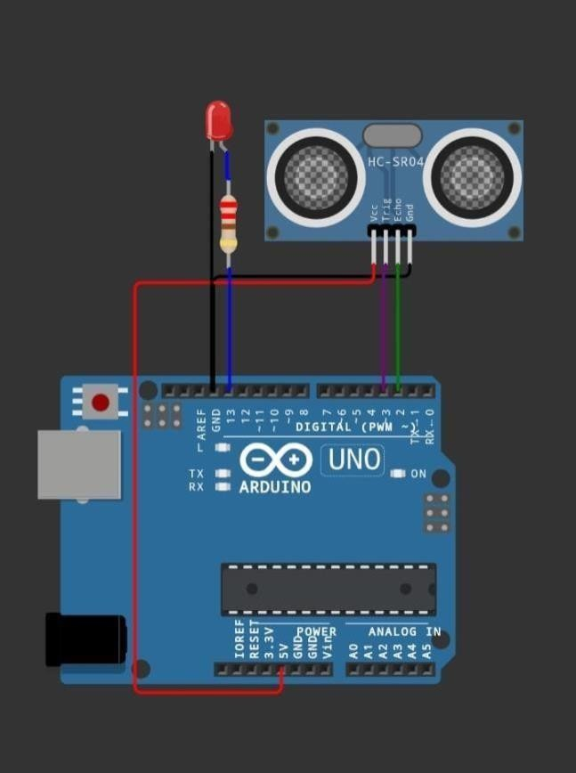

Reference: <https://wokwi.com/projects/290056311044833800>